APPLICANTS’ INFORMATION

THE SCHOOL
Otley All Saints CE Primary School was established as a one form entry primary in 2002 following the reorganisation of Otley’s schools. A new building extended and enhanced the new infant school, providing modern and attractive accommodation. The school makes good use of its facilities to offer a wide range of extra-curricular activities, including sports, music, nature and chess.

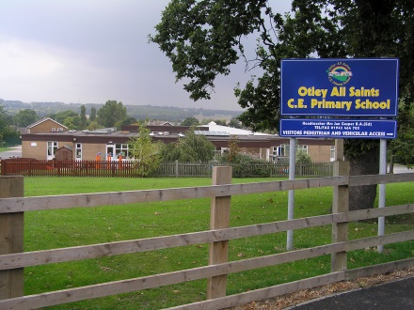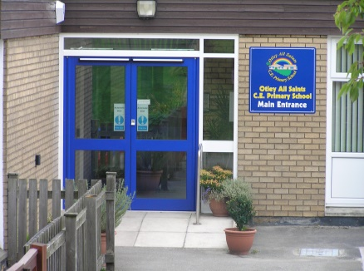

Currently there are 213 pupils on roll, plus a 26 place nursery. The majority of pupils transfer at eleven to Prince Henry’s Grammar School. Otley is an attractive and historic market town on the northwest boundary of Leeds, proud of its heritage and community spirit. The school enjoys strong links with community organisations, such as the Courthouse and the annual carnival, and with All Saints Church.

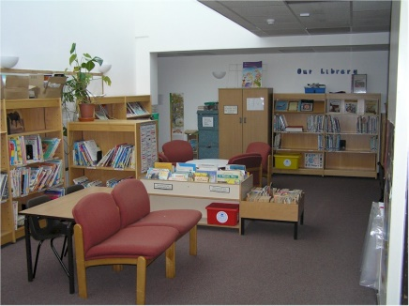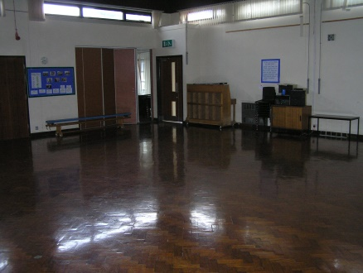

LEEDS
Leeds is the second largest metropolitan district in the UK. Two thirds of Leeds is Green Belt and is the home of some of the most beautiful scenery in Yorkshire.

Leeds city centre boasts a compact, lively and vibrant culture which is wrapped in a fusion of modern architecture and Victorian buildings. The mixture of
culture, business, history, arts, shopping and community life makes Leeds an up and coming cosmopolitan city.

The city centre is positioned at the crossroads of the M62 and the M1, and is just a few miles from the A1. Leeds Bradford International Airport is less than thirty minutes from the city centre. The new up and coming Leeds Supertram will provide fast and frequent services that will complement Metro Train and Regional Railways’ North East network.

Few cities can claim such a selection of cultural attractions. Leeds attractions include the Royal Armouries museum, Harewood House, Thackray Medical museum, Tropical World and Abbey House. It is the home to four theatres and has its own ballet and opera company. No matter what time of year it is, there are always plenty of opportunities to capture your favourite sports; football, test cricket, rugby league (Super League), rugby union and racing at Doncaster and Pontefract.

GUIDANCE NOTES ON COMPLETING THE APPLICATION FORM

Thank you for expressing an interest in joining our school. The enclosed application pack contains a number of documents providing background information about our school and the vacancy that we are advertising. We hope you will find this information useful and we look forward to hearing from you.

Making an Application
If you wish to be considered for this post please complete the enclosed application form providing full details of your education and employment history, including any unpaid or voluntary work. Where there are gaps in your employment please state the reasons why (e.g. gap year, career break, unemployed, etc).
You will note that we require details of two referees, one of which must be your current or most recent employer.
CVs are not accepted as part of the application process.

Supporting Information
This section of the form is very important. It gives you an opportunity to explain why you are applying and why you are the best person for this job. Use the job description and person specification as your guide and give specific examples, where possible, to demonstrate how you match the requirements for this post. If you do not have enough space, please attach a separate sheet.
Remember to sign the declaration on the final page of the application form. We accept electronic signatures.
Please submit your application via email to the address shown on the advert.
In addition to the application form, please submit a formal letter of application (up to 2 sides of A4) detailing your experience of teaching and learning and the impact your contribution will make in terms of raising standards at our school.
The closing date for applications is Friday 26th January 2024.

Selection Process
Those candidates who meet all the requirements for the post will be short listed and details of the interview programme will be confirmed in writing.
As part of the selection process, in addition to assessing your skills and knowledge against the requirements of this role, specific questions will be asked to assess your suitability to work with children.
Under the Disability Discrimination Act 1995 and 2005, we are legally required to consider making reasonable adjustments to ensure that disabled people are not disadvantaged in the recruitment and selection process. We are therefore committed to meeting, wherever possible, any needs you specify on the application form. Please contact the school if you need to discuss this in any detail.
We will consider any reasonable adjustments under the terms of the Disability Discrimination Act to enable an applicant with a disability (as defined under the act) to meet the requirements of the post.

Induction and Continuous Professional Development
The head teacher and governing body are committed to ensuring your well-being and continuous professional development in this role. On appointment the head teacher will discuss an appropriate induction programme with you that will help familiarise you with the culture of the school, local practices, policies and expectations.
You will be offered the opportunity to further develop your professional knowledge by participating in local training events and, where appropriate, working towards further qualifications.

Pre-employment Checks
If you are short listed we will normally take up references before the interview date. One of your referees must be your current or most recent employer. Two satisfactory references must be received before we confirm any offer of an appointment. The information we request will relate to salary, length of service, sickness absence record, skills and abilities, suitability for the job, disciplinary record and suitability to work with children.
Please provide an email address for your referee and a telephone contact number.
Copies of references or references that are addressed “to whom it may concern” will not be accepted. On receipt of references, your referees may be contacted to verify any discrepancies, anomalies or relevant issues as part of the recruitment verification process.

Disclosure and Barring Service Check
Employment at this school is subject to an enhanced DBS certificate and registration with the update service.
School will undertake a DBS Barred list check via BSC (DBS Team) before allowing the applicant to start work.
Shortlisted candidates will be asked to provide details of all unspent convictions and those that would not be filtered, prior to the date of the interview. You may be asked for further information about your criminal history during the recruitment process. If your application is successful, this self-disclosure information will be checked against information from the Disclosure & Barring Service before your appointment is confirmed. Under the Rehabilitation of Offenders Act 1974 (Exemption Amendment) Order 1986, there are a number of jobs where we must take account of convictions, even though they are ‘spent’. All posts at this school are regarded as such. However, spent and/or unspent convictions may not necessarily make you unsuitable for appointment.

Validation of Qualifications
All short listed candidates will be asked to bring original certificates of relevant qualifications to interview. These will be photocopied and kept on file and may be confirmed as genuine with the relevant awarding bodies.

Right to Work in the United Kingdom
Under the Asylum and Immigration Act 1996, it is a criminal offence to employ anyone who is not entitled to live or work in the United Kingdom. Applicants can expect us to ask for proof of this at interview stage, where you will be asked to provide some original documentation to confirm that you are eligible to work within the UK. Photographic proof of identity will also be required.

Medical Assessment
A satisfactory medical assessment will be required before we confirm any offer of an appointment.

Child Protection
This school is committed to safeguarding and promoting the welfare of children and young people and expects all staff and volunteers to share this commitment. We have a designated senior member of the leadership team who is responsible for referring and monitoring any suspected case of abuse. All members of staff will receive training in line with our child protection policy.

Whistle Blowing
We recognise that children cannot be expected to raise concerns in an environment where staff fail to do so. Therefore our policy is to ensure that all staff are made aware of their duty to raise concerns about any inappropriate attitude or actions of colleagues.
Code of Conduct and Personal Behaviour
The school believes that it is essential for standards of conduct at work to be maintained to ensure delivery of quality services and also to protect the well-being of all its employees and pupils.
The head teacher and governing body regard everyone working at our school as a role model to our pupils. As such employees should conduct themselves with integrity, impartiality and honesty. Furthermore, everyone in the school has an absolute duty to promote and safeguard the welfare of children. Registered teachers are in addition bound by the professional values of the Teachers’ Standards. While registered teachers are bound by the standards, the school considers the principles to apply to all staff employed at the school.

Equal Opportunities
We are committed to promoting best practice in our efforts to eliminate discrimination and to create a working and learning environment were all are treated fairly and with respect.
We take action to ensure that nobody is treated less favourably than anyone else because of their colour, race, ethnic or national origin, religion, gender, sexual orientation, disability or age.

Full details of all these policies are available in school.

